Children’s Product Certificate
Date of Certificate March 06, 2024
Product Overview
Product name: Electric Ride-on Car
Item Number: 370-150RD/JC111A
Date of Manufacture: 2024-01-19
Manufacture: PINGHU XH CHILDREN PRODUCTS CO., LTD
Address of Manufacture: NO.186, TONGCHE TOWN ROAD, XINCANG TOWN, PINGHU CITY, ZHEJIANG PROVINCE
Imported By: Aosom LLC
27150 SW Kinsman Rd
Wilsonville, OR 97070
T: 503.746.5886
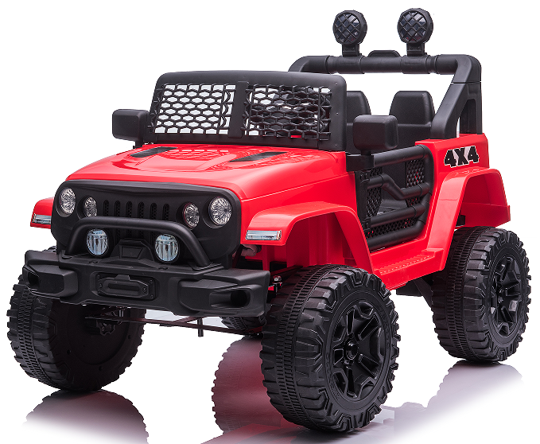

Product Reference Image

Testing and Records Overview
Bureau Veritas Testing Technical Service(Zhejiang) Co., Ltd
1F west, 6F east, 8F, Building B, No.66, Qingyi Road, Ningbo, Zhejiang, China
Cps.bureauveritas.com

Aosom LLC
27150 SW Kinsman Rd
Wilsonville, OR 97070
Corey Shull
T: 503.746.5886
Certification Issued and Test Records Maintained By
Aosom LLC certifies that the above product complies with the following rules, banes, regulations and standards:
Test Location and Contact Information
Test Date: Jan 19, 2024---Mar 06, 2024

