Children’s Product Certificate
Date of Certificate 2024-04-26
Product Overview
Product name: KIDS CHAIR
Item Number: 310-052GY
Date of Manufacture: 2024-04-30
Manufacture: ZHEJIANG LONGDIN FURNITURE CO.,LTD
Address of Manufacture: ZHEJIANG LONGDIN FURNITURE CO.,LTD
2 AREA,SUNSHINE INDUSTRY ZONE, DIPU TOWN, ANJI
COUNTY, ZHEJIANG PROVINCE, CHINA
Imported By: Aosom LLC
27150 SW Kinsman Rd
Wilsonville, OR 97070
T: 503.746.5886
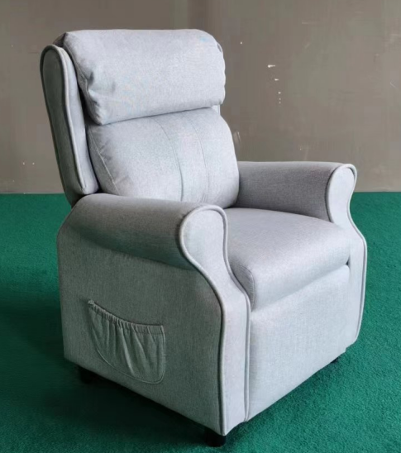

Product Reference Image

Testing and Records Overview
Bureau Veritas Testing Technical Service
(Zhejiang) Co.,Ltd.
1F west, 6F east, 7F east, 8F, Building B,
No.66,Qingyi Road, Ningbo, Zhejiang, China
Tel:86-574-87091333, Fax:86-574-
87971038
website:cps.bureauveritas.com
Aosom LLC
27150 SW Kinsman Rd
Wilsonville, OR 97070
Corey Shull
T: 503.746.5886
Certification Issued and Test Records Maintained By
Aosom LLC certifies that the above product complies with the following rules, banes, regulations and standards:
Test Location and Contact Information
Test Date: 2024.04.26
