Children’s Product Certificate
Date of Certificate 2025.11.22
Product Overview
Product name: Kids Scooter
Item Number: 371-029BU
Date of Manufacture: 2025-12-01
Manufacture: Hangzhou xinguang Bicycle Industry Co.,Ltd.
Address of Manufacture: 72-1 ZHA SHANG, TAOYUAN VILLAGE,
PUYANG TOWN, XIAOSHAN DISTRICT,
HANGZHOU CITY, ZHEJIANG PROVINCE, CHINA
Imported By: Aosom LLC
7777 Center Ave. Suite 430
Huntington Beach, CA 92647-9998 USA
T: 503.746.5886
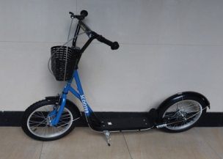

Product Reference Image

Testing and Records Overview
Eurofins Product Testing Service (Hangzhou) Co.,Ltd
Room 301-307, Room317-322,3/F. N0.1 Building 1,No.1180,Bin 'an Road,Binijiang District, Hangzhou,Zhejang,China
info.hz@cpt.eurofinscn.com
Aosom LLC
7777 Center Ave. Suite 430
Huntington Beach, CA 92647-9998 USA
Erin Flanagan
T:503.746.5886
PDreg@aosom.com
Certification Issued and Test Records Maintained By
Aosom LLC certifies that the above product complies with the following rules, banes, regulations and standards:
Test Location and Contact Information
Test Date: 2025.11.22
