Children’s Product Certificate
Date of Certificate 13 Mar, 2024
Product Overview
Product name: Swing Set
Item Number: 344-067V00MX (NS01016)
Date of Manufacture: 30 Mar,2024
Manufacture: Deyi Children Products Co., Ltd
Address of Manufacture: Dongguan City, Guangdong, China
Imported By: Aosom LLC
27150 SW Kinsman Rd
Wilsonville, OR 97070
T: 503.746.5886
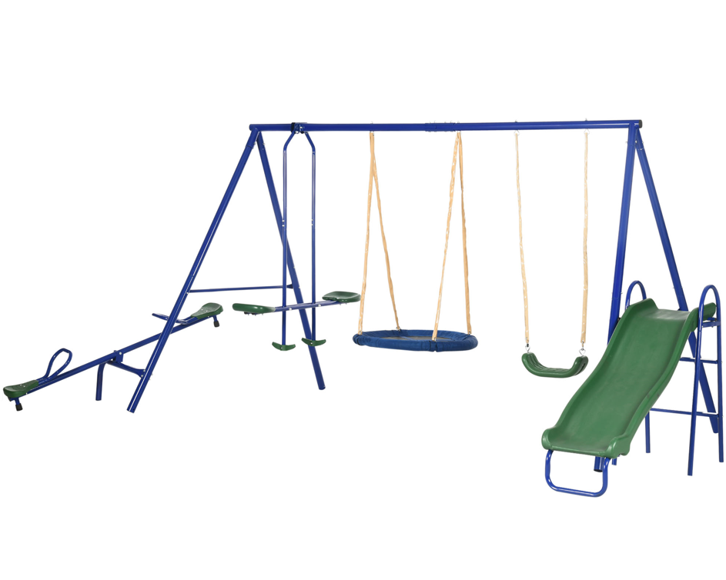

Product Reference Image

Testing and Records Overview
Aosom LLC
27150 SW Kinsman Rd
Wilsonville, OR 97070
Corey Shull
T: 503.746.5886
Intertek Testing Services LTD. ZHEJIANG
Building No.2, Juanhu Science and Technology
Innovation Park, No. 500 East Shuiyueting Road,
Haining City, Zhejiang Province,China. 314400
Phone:+86 57387137200
Fax:+86 57387137200
www.intertek.com
Certification Issued and Test Records Maintained By
Aosom LLC certifies that the above product complies with the following rules, banes, regulations and standards:
Test Location and Contact Information
Test Date: 13 Mar, 2024
