Children’s Product Certificate
Date of Certificate June 26, 2024
Product Overview
Product name: Wooden swing set with swingss
Item Number: 331-037V00ND（S04-641）
Date of Manufacture: Nov 25,2023
Manufacture: NINGBO BEST SWING COMPANY LIMITED
Address of Manufacture: NO.28，JINGANG ROAD, SOUTH BINHAI NEW ZONE, LIYANG TOWN, NINGHAI COUNTY, ZHEJIANG PROVINCE, CHINA
Imported By: Aosom LLC
27150 SW Kinsman Rd
Wilsonville, OR 97070
T: 503.746.5886
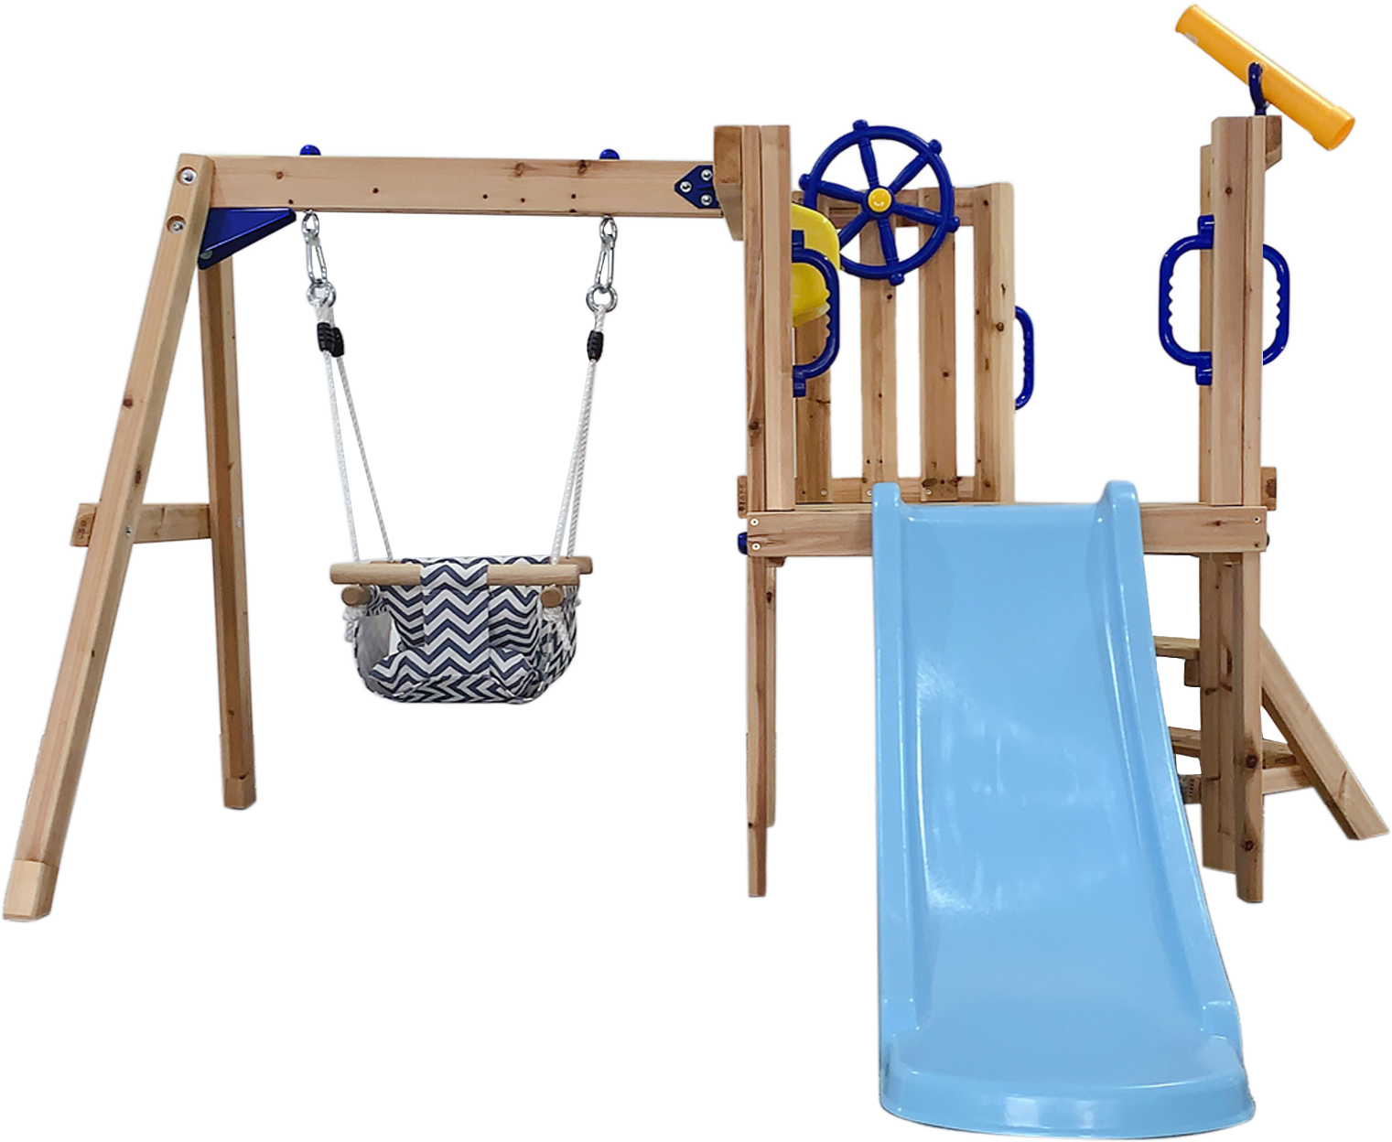

Product Reference Image

Testing and Records Overview
Aosom LLC
27150 SW Kinsman Rd
Wilsonville, OR 97070
Corey Shull
T: 503.746.5886
INTERTEK TESTING SERVICES LTD. ZHEJIANG
Building No.2, Juanhu Science and Technology
Innovation Park, No. 500 East Shuiyueting Road,
Haining City, Zhejiang Province,China.
Phone:+86 573 87137113
Fax:
aaron.xu@intertek.com
Certification Issued and Test Records Maintained By
Aosom LLC certifies that the above product complies with the following rules, banes, regulations and standards:
Test Location and Contact Information
Test Date: Apr 23, 2024
