Children’s Product Certificate
Date of Certificate April 10,2024
Product Overview
Product name: Baby Tricycle
Item Number: 370-198BK (JY-T08B）
Date of Manufacture: April 6,2024
Manufacture: NINGBO ELITE CYCLE CO.LTD.
Address of Manufacture: NO.36 PUYAN ROAD, XIAPU INDUSTRIAL PARK, BEILUN DISTRICT,NINGBO,CHINA
Imported By: Aosom LLC
27150 SW Kinsman Rd
Wilsonville, OR 97070
T: 503.746.5886
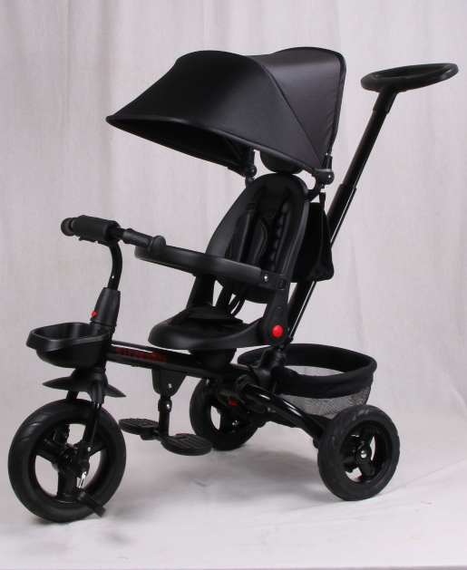

Product Reference Image

Testing and Records Overview
Aosom LLC
27150 SW Kinsman Rd
Wilsonville, OR 97070
Corey Shull
T: 503.746.5886
Intertek Testing Services Ltd .Zhejiang, Ningbo Branch
5/F No. 6 Building, Lingyun Industry Park, No.1177
Lingyun Road, Ningbo National Hi-Tech Zone, Ningbo,
China, 315000
Certification Issued and Test Records Maintained By
Aosom LLC certifies that the above product complies with the following rules, banes, regulations and standards:
Test Location and Contact Information
Test Date: April 8, 2024
