Children’s Product Certificate
Date of Certificate Apr. 16 ,2024
Product Overview
Product name: KID ROCKING HORSE
Item Number: 54-0016
Date of Manufacture: Mar.25,2024
Manufacture: ZHENJIANG PONYLAND TOYS CO.,LTD
Address of Manufacture: SUITE 210-211,NO.4 BUILDINGS,JINSHAN
BAODI COMMERCIAL PLAZA,ZHENJIANG,
JIANGSU,CHINA
Imported By: Aosom LLC
27150 SW Kinsman Rd
Wilsonville, OR 97070
T: 503.746.5886
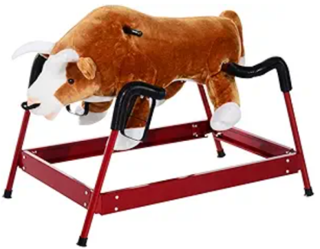

Product Reference Image

Testing and Records Overview
Test Date: Apr. 03,2024
Certification Issued and Test Records Maintained By
Test Location and Contact Information
Intertek Testing Services Ltd .Zhejiang, Ningbo
Branch
Phone: +86 21 61819181-6161
Fax: +86 21 61819180
www.intertek.com
www.intertek.com.cn

Aosom LLC
27150 SW Kinsman Rd
Wilsonville, OR 97070
Corey Shull
T: 503.746.5886
Aosom LLC certifies that the above product complies with the following rules, banes, regulations and standards:
Toy Safety Standard, ASTM F 963-23 Physical and Mechanical Hazards
Toy Safety Standard, ASTM F 963-23 Flammability of Toys
Toy Safety Standard, ASTM F 963-23 Heavy Metals
Toy Safety Standard, ASTM F 963-23 Phthalates Content
US CPSIA Section 101: Total Lead Content in Substrate
US CPSIA Section 108: Phthalates Content
US CPSIA Section 101: Total Lead Content in Paint / Surface Coating

