Children’s Product Certificate
Date of Certificate 17-APR, 2024
Product Overview
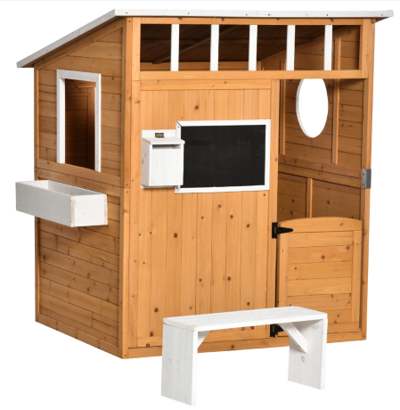
Product name: WOODEN PLAYHOUSE
Item Number: 345-022
Date of Manufacture: 20-APR, 2024
Manufacture: XIAMEN KINGSLEY IMPORT AND EXPORT CO.,LTD
Address of Manufacture: 4.ROOM 13,UNIT A,14/F,RAILWAY BUILDING,NO.878,XIAHE ROAD,SIMING DISTRIC,XIAMEN Fujian China
Imported By: Aosom LLC
27150 SW Kinsman Rd
Wilsonville, OR 97070
T: 503.746.5886

Product Reference Image

Testing and Records Overview
Certification Issued and Test Records Maintained By
Aosom LLC
27150 SW Kinsman Rd
Wilsonville, OR 97070
Corey Shull
T: 503.746.5886
INTERTEK TESTING SERVICES LTD. ZHEJIANG Building No.2, Juanhu Science and Technology
Innovation Park, No. 500 East Shuiyueting Road,
Haining City, Zhejiang Province,China. 314400
Tel: +86 573 87137200
www.intertek.com

Test Location and Contact Information
Test Date: DEC 26,2023
Aosom LLC certifies that the above product complies with the following rules, banes, regulations and standards:
