Children’s Product Certificate
Date of Certificate March 27, 2024
Product Overview
Product name: Motor bike
Item Number: 370-188V80YL/JC916
Date of Manufacture: 2024-03-26
Manufacture: Pinghu XH Children Products Co., Ltd
Address of Manufacture: No. 186 Tongche Road, Pinghu City, Zhejiang Province, China
Imported By: Aosom LLC
27150 SW Kinsman Rd
Wilsonville, OR 97070
T: 503.746.5886
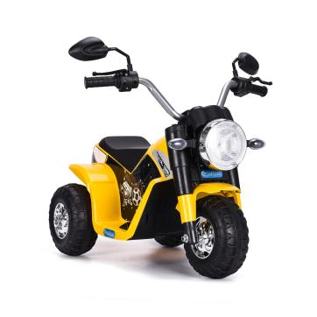

Product Reference Image

Testing and Records Overview
Bureau Veritas Testing Technical Service(Zhejiang) Co., Ltd
1F west, 6F east, 8F, Building B, No.66, Qingyi Road, Ningbo, Zhejiang, China
Cps.bureauveritas.com
Eurofins MTS Consumer Product Testing (Shanghai) Co., Ltd.
No.105, Guangzhong Road, Minhang, Shanghai, China

Test Date: Jan 30, 2024---Mar 27, 2024
Jan 29, 2024---May 22, 2024

Aosom LLC
27150 SW Kinsman Rd
Wilsonville, OR 97070
Corey Shull
T: 503.746.5886
Certification Issued and Test Records Maintained By
Aosom LLC certifies that the above product complies with the following rules, banes, regulations and standards:

