Children’s Product Certificate
Date of Certificate December. 17,2025
Product Overview
Product name: KID ROCKING HORSE
Item Number: 330-122
Date of Manufacture: December. 17,2025
Manufacture: Yizheng Jian Lin Arts Company
Address of Manufacture: Yizheng City, JiangSu Province, China
Imported By: Aosom LLC
7777 Center Ave. Suite 430
Huntington Beach, CA 92647-9998
T: 503.746.5886

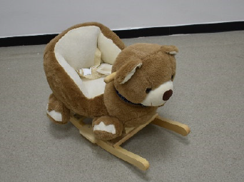

Product Reference Image

Testing and Records Overview
Test Date:December. 17,2025

Test Location and Contact Information
Aosom LLC
7777 Center Ave. Suite 430
Huntington Beach, CA 92647-9998
Corey Shull
T:503.746.5886
corey@aosom.com

Bureau Veritas TestingTechnical Service (Zhejiang)Co.,Ltd1F, 6F east, 7F east, 8F,Building B, No.66,QingyiRoad, Juxian Sub-district,High-tech Zone,Ningbo,Zhejiang, ChinaTel:86-574-87091333,
Fax:86-574-87971038
website:cps.bureauveritas.com

Certification Issued and Test Records Maintained By

Aosom LLC certifies that the above product complies with the following rules, banes, regulations and standards:
Toy Safety Standard, ASTM F 963-23 Physical and Mechanical Hazards
Toy Safety Standard, ASTM F 963-23 Flammability of Toys
Toy Safety Standard, ASTM F 963-23 Heavy Metals
Toy Safety Standard, ASTM F 963-23 Phthalates Content
US CPSIA Section 101: Total Lead Content in Substrate
US CPSIA Section 108: Phthalates Content
US CPSIA Section 101: Total Lead Content in Paint / Surface Coating

