Children’s Product Certificate
Date of Certificate May. 07,2024
Product Overview
Product name: Children Car
Item Number: 370-118V80(JE1001)
Date of Manufacture: Mar. 07,2024
Manufacture: ZHEJIANG JIAJIA RIDE-ON CO.,LTD
Address of Manufacture: PINGHU CITY, ZHEJIANG PROVINCE
Imported By: Aosom LLC
27150 SW Kinsman Rd
Wilsonville, OR 97070
T: 503.746.5886
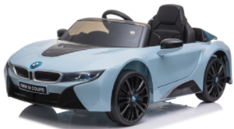

Product Reference Image

Testing and Records Overview
Aosom LLC
27150 SW Kinsman Rd
Wilsonville, OR 97070
Corey Shull
T: 503.746.5886
Intertek Testing Services Wuxi Ltd.
No.8 Fubei Road, Xishan Economic Development
Zone, Wuxi, Jiangsu, China. 214101
Certification Issued and Test Records Maintained By
Aosom LLC certifies that the above product complies with the following rules, banes, regulations and standards:
Test Location and Contact Information
Test Date: May. 7,2024

