Children’s Product Certificate
Date of Certificate 2026-05-15
Product Overview
Product name: Kids Kitchen Playset
Item Number: 350-217V80PK
Date of Manufacture: 2026-03-25
Manufacture: Zhejiang Taixing Kid Toy CO., LTD
Address of Manufacture: Jiaoyang Industry Zone,Taishun,Wenzhou City,Zhejiang,China
Imported By: Aosom LLC
27150 SW Kinsman Rd
Wilsonville, OR 97070
T: 503.746.5886
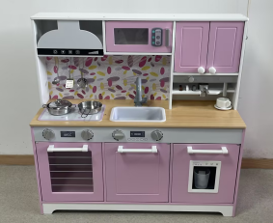

Product Reference Image

Testing and Records Overview
Eurofins MTS Consumer Product Testing (Shanghai) Co., Ltd
Building 1, No. 105, Guangzhong Road, Zhuanqiao, Minhang District, Shanghai, China.
Phone: +86 21-2350 9600
Website: www.eurofins.cn
E-maill: info.shmts@cpt.eurofinscn.com
Aosom LLC
27150 SW Kinsman Rd
Wilsonville, OR 97070
Corey Shull
T: 503.746.5886
Email:corey@aosom.com
Certification Issued and Test Records Maintained By
Aosom LLC certifies that the above product complies with the following rules, banes, regulations and standards:
Test Location and Contact Information
Test Date: 2026.04.10-5.14

