Children’s Product Certificate
Date of Certificate Jul 18,2025
Product Overview
Product name: Pedal go kart
Item Number: 370-448V00BK (G205)
Date of Manufacture: AUG 20,2025
Manufacture: PINGHU KADING BABY CARRIER CO.,LTD
Address of Manufacture: 1ST FLOOR BLDG 1 NO99 TONGCHE RD
XINCANG TOWN ,PINGHU CITY , JIAXING CITY ,ZHEJIANG,CHINA
Imported By: Aosom LLC
7777 Center Ave. Suite 430
Huntington Beach, CA 92647-9998
T: 503.746.5886

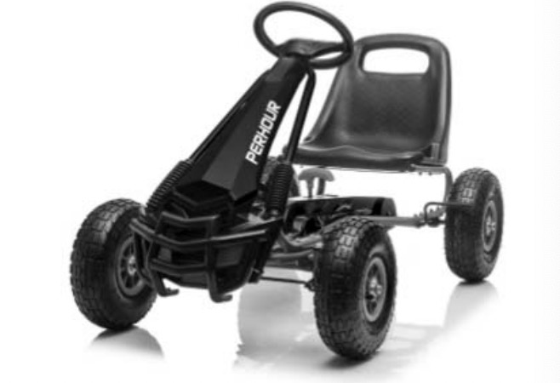

Product Reference Image

Testing and Records Overview
Intertek Testing Services Wuxi Ltd.
.8 Fubei Road, Xishan Economic Development
Zone, Wuxi, Jiangsu, China
Tel: +86 510 8821 4567
Fax: +86 510 8820 0428
cindy.chu@intertek.com
cindy.chu@intertek.com
cindy.chu@intertek.com

Test Location and Contact Information
Test Date: Jul 7,2025
4
Aosom LLC
7777 Center Ave. Suite 430
Huntington Beach, CA 92647-9998
Corey Shull
T:503.746.5886
corey@aosom.com

Certification Issued and Test Records Maintained By

Aosom LLC certifies that the above product complies with the following rules, banes, regulations and standards:
ASTM F963-23 Standard Consumer Safety Specification for Toy Safety
Consumer Product Safety Act section 14(a)(5) tracking labels forChildren Products
U.S. CFR Title 16 (CPSC Regulations) Mechanical and Physical Tests
1500.48 Sharp Point
1500.49 Sharp Edge
U.S. CFR Title 16 (CPSC Regulations) Part 1500.3(c)(6)(vi)
Flammability Test On Rigid and Pliable Solids
U.S. Consumer Product Safety Improvement Act 2008 title I, section
101 for total Lead content in surface coating
U.S. Consumer Product Safety Improvement Act 2008 title I, section
101 and 15 U.S. Code § 1278a for total Lead content in non-surface coating materials (substrate)
U.S. Consumer Product Safety Improvement Act 2008 title I, section
101 and 15 U.S. Code § 1278a for total Lead content in surface coating
U.S. 16 CFR Part 1303 total Lead content
U.S. Consumer Product Safety Improvement Act 2008 title I, section
101 for total Lead content in non-surface coating materials (substrate)
US Consumer Product Safety Improvement Act 2008 Title I, Sec 108(a)
& (b)(3) and US 16 CFR Part 1307 for Prohibition of Children’s Toys
and Child Care Articles Containing Specified Phthalates
U.S. ASTM F963-23 Section 4.3.5.1 on Total Lead Content in Surface
Coating
U.S. ASTM F963-23 Section 4.3.5.1 on Soluble Elements Content in Surface
Coating
U.S. ASTM F963-23 Section 4.3.5.2 on Soluble Elements Content in
substrate
U.S. ASTM F963-23 Section 4.3.5.2 on Total Lead Content in Substrate
ASTM F963-23 Section 4.3.8 on Phthalates Content
U.S. Consumer Product Safety Improvement Act 2008 title I, section 101
for total Lead content in surface coating

