Children’s Product Certificate
Date of Certificate April 28,2026
Product Overview
Product name: kids soft play set
Item Number: 3D0-039V00MX(SF-1777)
Date of Manufacture: May 26,2026
Manufacture: Dongguan City Baby Furniture co.,Ltd
Address of Manufacture: Dangkeng Road, Shangtun No.3 lndustrial Area, Liaobu Town, Dongguan City, CHINA
Imported By: Aosom LLC
7777 Center Ave. Suite 430
Huntington Beach, CA 92647-9998 USA
T: 503.746.5886
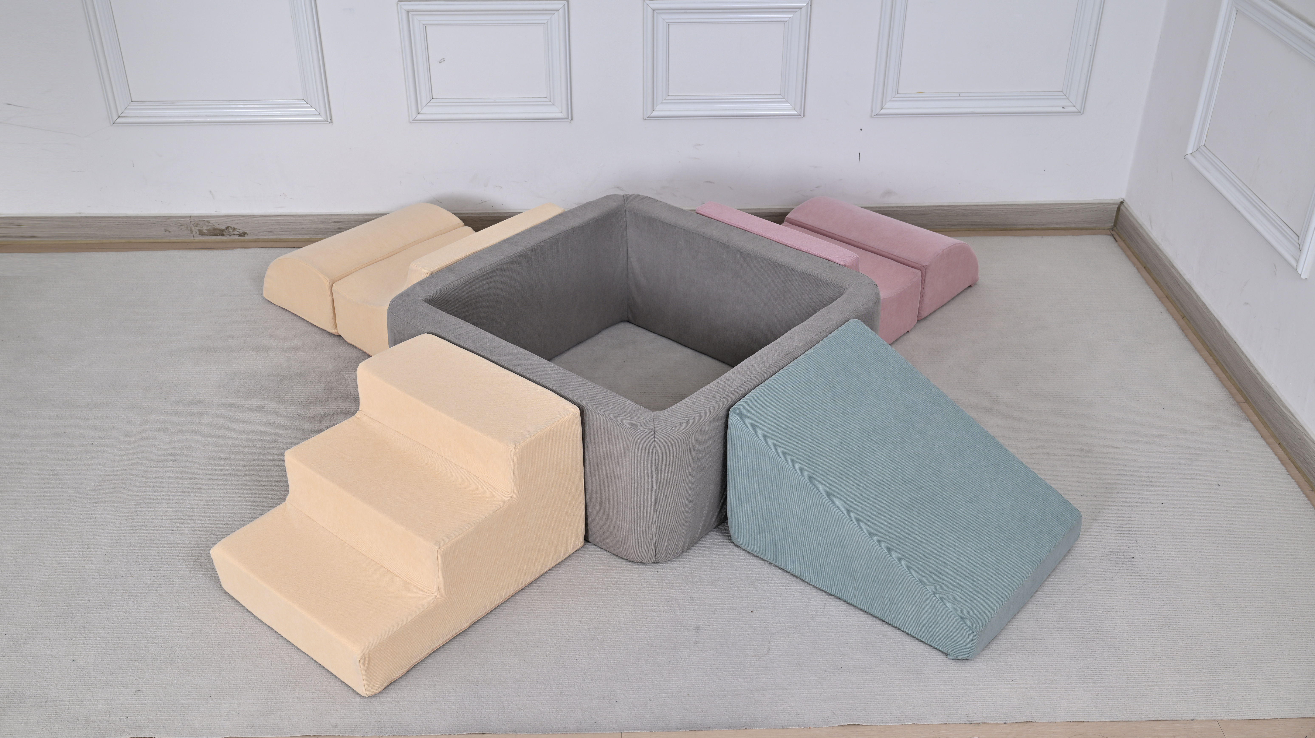

Product Reference Image

Testing and Records Overview
Aosom LLC
7777 Center Ave. Suite 430
Huntington Beach, CA 92647-9998 USA
Corey Shull
T:503.746.5886
corey@aosom.com

Eurofins Product Testing Seryice (Hangzhou)Co.. Ltd.
Room 301-307, Room317-322,3/F., NO.1 Building 1, No.1180, Bin'an Road, Binjiang District, Hangzhou, Zhejiang, China
Phone: +86 571 87203730
Stacey.Zhang@cpt.eurofinscn.com

Certification Issued and Test Records Maintained By
Aosom LLC certifies that the above product complies with the following rules, banes, regulations and standards:
Test Location and Contact Information
Test Date: From 25-Mar-2026 to 28-Apr-2026, 2022

