Children’s Product Certificate
Date of Certificate 11-Jun-2026
Product Overview
Product name: Kids Kitchen Playset
Item Number: 350-190V00PK(922-211)
Date of Manufacture: 11-Jun-2026
Manufacture: SHANTOU CITY CHENGHAI DISTRICT BEIDIYUAN TOYS
FACTORY
Address of Manufacture: LONGWEINORTH,NANWAN VILLAGE, LIANXIA TOWN,CHENGHAIDISTRICT,SHANTOU CITY,GUAGNDONG PROVINCE,CHINA
Imported By: Aosom LLC
7777 Center Ave. Suite 430
Huntington Beach, CA 92647-9998 USA
Erin Flanagan
T:503.746.5886
PDreg@aosom.com

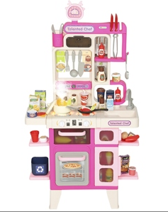

Product Reference Image

Testing and Records Overview
Aosom LLC
7777 Center Ave. Suite 430
Huntington Beach, CA 92647-9998 USA
Erin Flanagan
T:503.746.5886
PDreg@aosom.com

Eurofins MTS Consumer Product Testing (Shanghai)Co., Ltd.
NO.105 GUANGZHONG RD., ZHUANQIAO TOWN
MINHANG, SHANGHAI, SHANGHAI CHINA 201108
Phone: +86-21-23509600
Fax: +86-21-23509700
CLEMENT.LI@CPT.EUROFINSCN.COM

Certification Issued and Test Records Maintained By
Aosom LLC certifies that the above product complies with the following rules, banes, regulations and standards:
Test Location and Contact Information
Test Date: 11-Jun-2026
