Ningbo mingpeng industry and trade co., LTD Product Certificate
Date of Certificate Jan 22, 2026
Product Overview
Product name: Multi-Gaming Ball Table
Item Number: A70-108V80MX
Date of Manufacture: May 20, 2025
Manufacture: Ningbo mingpeng industry and trade co., LTD
Address of Manufacture: Luguang bridge, hengxi village, hengxi town, yinzhou district, ningbo city,ZHEIANG.CHINA.
Imported By: Aosom LLC
27150 SW Kinsman Rd
Wilsonville, OR 97070
T: 503.746.5886
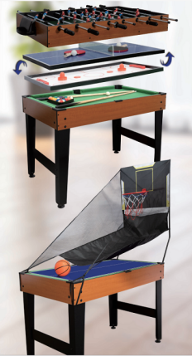

Product Reference Image

Testing and Records Overview
Aosom LLC
27150 SW Kinsman Rd
Wilsonville, OR 97070
Corey Shull
T: 503.746.5886

Bureau Veritas Shenzhen Co., Ltd., Dongguan Branch
No. 96, Guantai Road (Houjie Section), Houjie Town, Dongguan,Guangdong,
P.R.C Post Code: 523942

Test Location and Contact Information
Test Date:Jan 22, 2026
Certification Issued and Test Records Maintained By
Aosom LLC certifies that the above product complies with the following rules, banes, regulations and standards:
Test Requested | Conclusion
(#)Mechanical hazards requirements of ASTM F963-23, “Standard consumer safety specification for toy safety”. | PASS
(#)Flammability requirement of solids under ASTM F963-23 section 4.2 according to Annex A5, "Flammability testing procedure for solids and soft toys". | PASS
(#)Phthalates (BBP, DBP, DEHP, DINP, DIBP, DPENP, DHEXP & DCHP) content  requirements of ASTM F963-23, "Standard Consumer Safety Specification for Toy  Safety," Section 4.3.8. | PASS
(#)Soluble Heavy Metals Content in Surface Coating –ASTM F963-23, Section 4.3.5.1(2) | PASS
(#)Soluble Heavy Metals Content in Substrate –ASTM F963-23, Section 4.3.5.2(2)(b) | PASS
(#)Total Lead Content in Surface Coating – ASTM International Standard ASTM F963-23, Section 4.3.5.1(1) | PASS
(#)Total Lead Content in Substrate – ASTM International Standard ASTM F963-23, Section 4.3.5.2(2)(a) | PASS
(#)Phthalates Content in Children’s Toys and Childcare Articles – Proposed Amendment rule Consumer Product Safety Improvement Act (CPSIA) of 2008, Section 108(a) and 108(b)(3) - BBP, DBP, DEHP, DINP, DIBP, DPENP, DHEXP & DCHP Content | PASS
(#)Total Lead Content in Surface Coating – Consumer Product Safety Improvement Act (CPSIA) of 2008 Sec. 101(f) | PASS
(#)Total Lead Content in Substrate Materials – Consumer Product Safety Improvement Act (CPSIA) of 2008 Sec. 101(a)(2) | PASS

