Children’s Product Certificate
Date of Certificate MAY 13, 2024
Product Overview
Product name: Electric Ride-on Car
Item Number: 370-260V80GN
Date of Manufacture: 2024-05-15
Manufacture: PINGHU XH CHILDREN PRODUCTS CO., LTD
Address of Manufacture: NO.186, TONGCHE TOWN ROAD, XINCANG TOWN, PINGHU CITY, ZHEJIANG PROVINCE
Imported By: Aosom LLC
27150 SW Kinsman Rd
Wilsonville, OR 97070
T: 503.746.5886
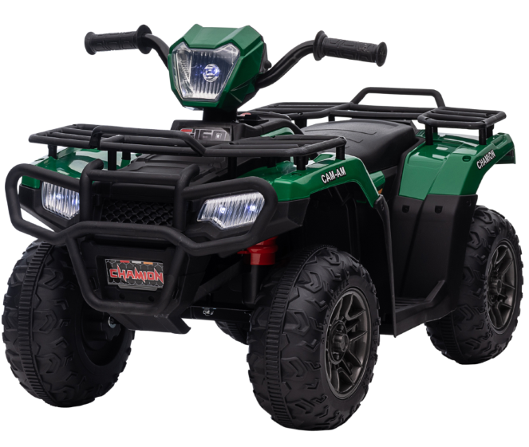

Product Reference Image

Testing and Records Overview
Eurofins MTS Consumer Product Testing(Shanghai) Co., Ltd
No. 105, Guangzhong Road, Minhang, Shanghai, China
www.eurofins.cn/cpt
Bureau Veritas Testing Technical Service
(Zhejiang) Co.,Ltd
1F west, 6F east, 7F east, 8F, Building B,
No.66,Qingyi Road, Ningbo, Zhejiang, China
website:cps.bureauveritas.com

Bureau Veritas Testing Technical Service(Zhejiang)Co.,Ltd
1F west,6F east,7F EAST,8F,Building B,No.66 Qingyi Road,Ningbo Zhejiang,China
Website:cps.bureauveritas.com
Aosom LLC
27150 SW Kinsman Rd
Wilsonville, OR 97070
Corey Shull
T: 503.746.5886
Certification Issued and Test Records Maintained By
Aosom LLC certifies that the above product complies with the following rules, banes, regulations and standards:
Test Location and Contact Information
Test Date: 26-Feb-2024 to 13-May-2024
