Children’s Product Certificate
Date of Certificate Nov.20th,2025
Product Overview
Product name: Children Car
Item Number: 370-211V80BU(JT5008)
Date of Manufacture: Dec. 18th,2025
Manufacture: ZHEJIANG JIAJIA RIDE-ON CO.,LTD
Address of Manufacture: PINGHU CITY, ZHEJIANG PROVINCE
Imported By: Aosom LLC
7777 Center Ave. Suite 430
Huntington Beach, CA 92647-9998 USA
T:503.746.5886

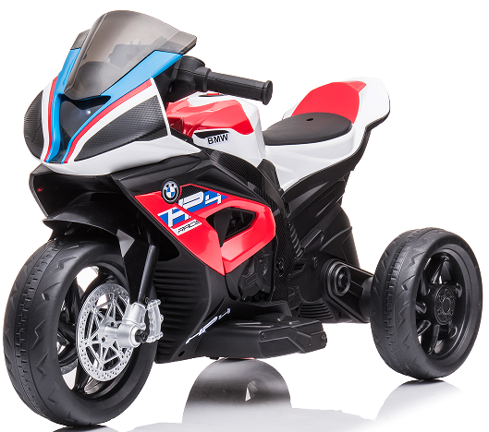

Product Reference Image

Testing and Records Overview
Aosom LLC
7777 Center Ave. Suite 430
Huntington Beach, CA 92647-9998 USA
Corey Shull
T:503.746.5886
corey@aosom.com

Intertek Testing Services Wuxi Ltd.
No.8 Fubei Road, Xishan Economic Development
Zone, Wuxi, Jiangsu, China. 214101
Certification Issued and Test Records Maintained By
Aosom LLC certifies that the above product complies with the following rules, banes, regulations and standards:
Test Location and Contact Information
Test Date: Nov.20,2025
