Children’s Product Certificate
Date of Certificate Dec 31，2025

Product Overview
Product name: Electric Ride on car
Item Number: 370-367V80GN(8858)
Date of Manufacture: Aug.10 ,2025
Manufacture: YIWU ZHIHUIXING TOYS CO.,LTD
Address of Manufacture: 189 QIUSHI ROAD, BEIYUAN DISTRICT, YIWU, ZHEJIANG, CHINA.
Imported By: Aosom LLC
7777 Center Ave. Suite 430
Huntington Beach, CA 92647-9998 USA

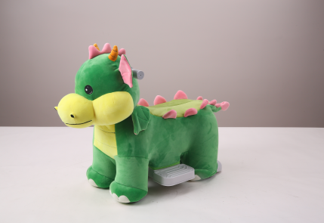

Product Reference Image

Testing and Records Overview
Aosom LLC
7777 Center Ave. Suite 430
Huntington Beach, CA 92647-9998 USA
corey@aosom.com

Intertek Testing Services Shenzhen Ltd.

West Side of 1/F and 3,4,5/F of Bldg. 1, 1-5/F of Bldg.
3, Yuanzheng Science and Technology Industrial
Park, No.4012, Wuhe Ave. North, Bantian Street,
Longgang District, Shenzhen, China
Certification Issued and Test Records Maintained By
Aosom LLC certifies that the above product complies with the following rules, banes, regulations and standards:
Test Location and Contact Information
Test Date: Aug. 01,2025

