Children’s Product Certificate
Date of Certificate 05 Nov, 2025
Product Overview
Product name: Children Plastic Tunnel
Item Number: 349-001V00MX（LY-1602）
Date of Manufacture: 15-AUG-2025
Manufacture: Liyou Industrial Co.,Ltd
Address of Manufacture: Yangwan industrial zone, QiaoXia Town, Yongjia County,Zhejiang,CHINA 325106
Imported By: Aosom LLC
7777 Center Ave. Suite 430
Huntington Beach, CA 92647-9998 USA
T: 503.746.5886
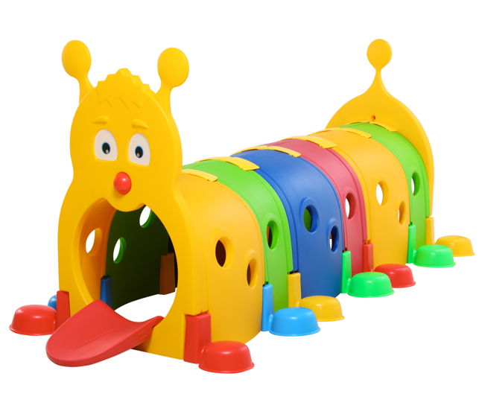

Product Reference Image

Testing and Records Overview
Intertek Testing Services Ltd .Zhejiang, Ningbo Branch
4F's Area 2-3 , 5F, No.6 Building,Lingyun Industry Park, No.1177 Lingyun Road, Ningbo National Hi-Tech Zone, Ningbo,China,315000
Tel: +86 574 8818 3650
Fax: +86 574 8818 3680
Jim.jin@intertek.com
Aosom LLC
7777 Center Ave. Suite 430
Huntington Beach, CA 92647-9998 USA
Erin Flanagan
T:503.746.5886
PDreg@aosom.com

Certification Issued and Test Records Maintained By
Test Location and Contact Information
Test Date: 24 Oct, 2025
Aosom LLC certifies that the above product complies with the following rules, banes, regulations and standards:

