Children’s Product Certificate
Date of Certificate May. 28, 2024
Product Overview
Product name: KID'S DRESSING TABLE PLAYSET
Item Number: 350-165V00MX(661-127)
Date of Manufacture: June 18, 2024
Manufacture: BOHUI PLASTIC TOYS CO.,LTD.
Address of Manufacture: CHENGHAI DISTRICT, SHANTOU CITY, GUANGDONG PROVINCE,CHINA

Imported By: Aosom LLC
27150 SW Kinsman Rd
Wilsonville, OR 97070
T: 503.746.5886
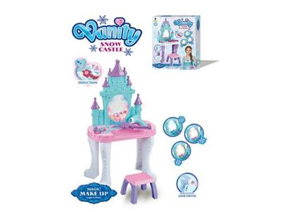

Product Reference Image

Testing and Records Overview
Aosom LLC
27150 SW Kinsman Rd
Wilsonville, OR 97070
Corey Shull
T: 503.746.5886
SGS-CSTC Standard Technical Services Co., Ltd Shenzhen Branch Testing Center Hardlines
Room 101-901, Plant4 & Room 101, Plant2 & Room 101, Plant3 & Room 301-501, Plant 3, jianghao (Bantian) industrial Plant Area, No.430, Jihua Road,Banian Community, Bantian Street,Longgang District, Shenzhen, Guangdong, China 518129
Tel: (86-755)25328888
www.sgsgroup.com.cn

Tel: +8620 28209114 intertek.com.cn
intertek.com
Test Location and Contact Information
Certification Issued and Test Records Maintained By
Test Date: March 12, 2024
Aosom LLC certifies that the above product complies with the following rules, banes, regulations and standards:
