Children’s Product Certificate
Date of Certificate May 26,2024
Product Overview
Product name: Kids Rocking Horse
Item Number: 330-115
Date of Manufacture: MAY 20,2024
Manufacture: YZ SUNSHINE ARTS&CRAFTS CO.,LTD
Address of Manufacture: Yangzhou CITY, JIANGSU PROVINCE
Imported By: Aosom LLC
27150 SW Kinsman Rd
Wilsonville, OR 97070
T: 503.746.5886

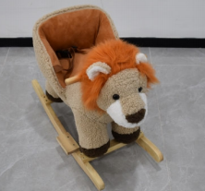

Product Reference Image

Testing and Records Overview
Aosom LLC
27150 SW Kinsman Rd
Wilsonville, OR 97070
Corey Shull
T: 503.746.5886
Intertek Testing Services Wuxi Ltd
No.8 Fubei Road, Xishan Economic Development
Zone, Wuxi, Jiangsu, China. 214101
江苏省无锡市锡山经济开发区府北路 8 号 214101

Certification Issued and Test Records Maintained By
Aosom LLC certifies that the above product complies with the following rules, banes, regulations and standards:
Test Location and Contact Information
Test Date: MAY 10,2024
