Children’s Product Certificate
Date of Certificate Nov.20th,2025
Product Overview
Product name: Children Car
Item Number: 370-211V80BU(JT5008)
Date of Manufacture: Dec. 18th,2025
Manufacture: ZHEJIANG JIAJIA RIDE-ON CO.,LTD
Address of Manufacture: PINGHU CITY, ZHEJIANG PROVINCE
Imported By: Aosom LLC
7777 Center Ave. Suite 430
Huntington Beach, CA 92647-9998 USA
T:503.746.5886

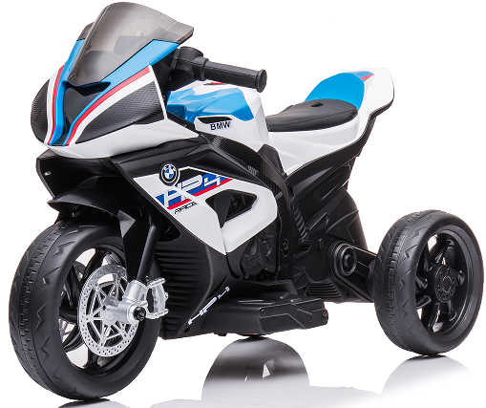

Product Reference Image

Testing and Records Overview
Aosom LLC
7777 Center Ave. Suite 430
Huntington Beach, CA 92647-9998 USA
Corey Shull
T:503.746.5886
corey@aosom.com

Intertek Testing Services Wuxi Ltd.
No.8 Fubei Road, Xishan Economic Development
Zone, Wuxi, Jiangsu, China. 214101
PHONE: 86-510-88214567
FAX: 86-510-88200428
EMAIL ADDRESS: JESSICA.LU@INTERTEK.COM
Certification Issued and Test Records Maintained By
Aosom LLC certifies that the above product complies with the following rules, banes, regulations and standards:
Test Location and Contact Information
Test Date: Nov.20,2025
