Children’s Product Certificate
Date of Certificate May 24, 2024
Product Overview
Product name: Electric Ride-on Car
Item Number: 370-260V80PK/JC915
Date of Manufacture: 2024-01-30
Manufacture: Chizhou JC Children Products Co., Ltd
Address of Manufacture: Matang industrial zone, Dingqiao town, Qingyang district, Chizhou city, Auhui province
Imported By: Aosom LLC
27150 SW Kinsman Rd
Wilsonville, OR 97070
T: 503.746.5886
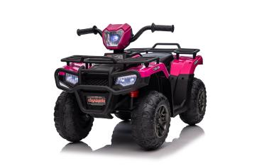

Product Reference Image

Testing and Records Overview
Bureau Veritas Testing Technical Service(Zhejiang) Co., Ltd
1F west, 6F east, 8F, Building B, No.66, Qingyi Road, Ningbo, Zhejiang, China
Cps.bureauveritas.com
Eurofins MTS Consumer Product Testing (Shanghai) Co., Ltd.
No.105, Guangzhong Road, Minhang, Shanghai, China

Test Date: Jan 30, 2024---Apr 24, 2024
Feb 02, 2024---May 13, 2024

Aosom LLC
27150 SW Kinsman Rd
Wilsonville, OR 97070
Corey Shull
T: 503.746.5886
Certification Issued and Test Records Maintained By
Aosom LLC certifies that the above product complies with the following rules, banes, regulations and standards:

