Children’s Product Certificate
Date of Certificate 2026-6-12
Product Overview
Product name: Kids Scooter
Item Number: 371-048V00GN(371-048V00)
Date of Manufacture: 2026-6-12
Manufacture: Hangzhou xinguang Bicycle Industry Co.,Ltd.
Address of Manufacture: 72-1 ZHA SHANG, TAOYUAN VILLAGE,
PUYANG TOWN, XIAOSHAN DISTRICT,
HANGZHOU CITY, ZHEJIANG PROVINCE, CHINA
Imported By: Aosom LLC
7777 Center Ave. Suite 430
Huntington Beach, CA 92647-9998 USA
T:503.746.5886
corey@aosom.com
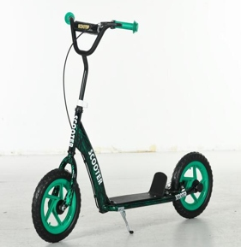

Product Reference Image

Testing and Records Overview
INTERTEK TESTING SERVICES LTD.ZHEJIANG
Building No.2,Juanhu Science and Technologylnnovation Park, No.500 East Shuiyueting Road,Haining City, Zhejiang Province,China.314400
Tel:+8657387137200
Jim.jin@intertek.com
Aosom LLC
7777 Center Ave. Suite 430
Huntington Beach, CA 92647-9998 USA
Corey Shull
T:503.746.5886
corey@aosom.com
Certification Issued and Test Records Maintained By
Aosom LLC certifies that the above product complies with the following rules, banes, regulations and standards:
Test Location and Contact Information
Test Date: 2026-6-12
