Children’s Product Certificate
Date of Certificate February 27, 2026
Product Overview
Product name: Toy Car
Item Number: 370-429V80GN (HZB-007)
Date of Manufacture: May 10, 2026
Manufacture: CHIZHOU HAIZHIBAO CHILDREN PRODUCTS CO., LTD
Address of Manufacture: MATANG INDUSTRIAL PARK, DINGQIAO TOWN, QINGYANG COUNTY, CHIZHOU CITY,CHINA
Imported By: Aosom LLC
7777 Center Ave. Suite 430
Huntington Beach, CA 92647-9998 USA
T: 503.746.5886
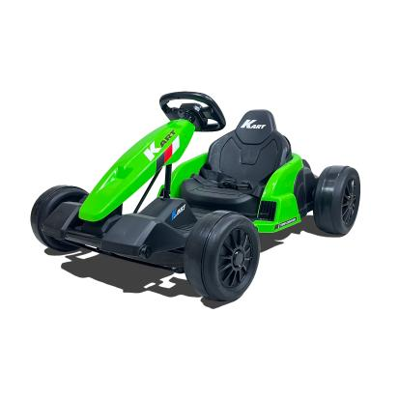

Product Reference Image

Testing and Records Overview
Aosom LLC
7777 Center Ave. Suite 430
Huntington Beach, CA 92647-9998 USA
Corey Shull
T:503.746.5886
corey@aosom.com

Bureau Veritas Testing Technical Service (Zhejiang) Co.,Ltd
1F, 6F east, 7F east, 8F, Building B,
No.66,Qingyi Road, Juxian Sub-district,
High-tech Zone,Ningbo, Zhejiang, China
Tel:86-574-87091333,
Fax:86-574-87971038
lilyli.li@bureauveritas.com

87971038
Fax:86-574- 87971038
website:cps.bureauveritas.com

87971038
website:cps.bureauveritas.com

Certification Issued and Test Records Maintained By
Aosom LLC certifies that the above product complies with the following rules, banes, regulations and standards:
Test Location and Contact Information
Test Date: December 11,2025

