Children’s Product Certificate
Date of Certificate 28 Aug, 2025
Product Overview
Product name: Foot-Floor Toy
Item Number: 370-459V00BK（G28）
TEST REPORT: SHAH01843024S3
Date of Manufacture: 28 Aug, 2025
Manufacture: PINGHU CITY GOLDTIER CHILDREN PRODUCTS MANUFACTURE CO.,LTD
Address of Manufacture: XINMIAO INDUSTRY ZONE XINCANG TOWN, PINGHU CITY, ZHEJIANG PROVINCE, CHINA
Imported By: Aosom LLC
7777 Center Ave Suite 430, Huntington Beach, CA 92647-9998 USA
T:001-877-644-9366

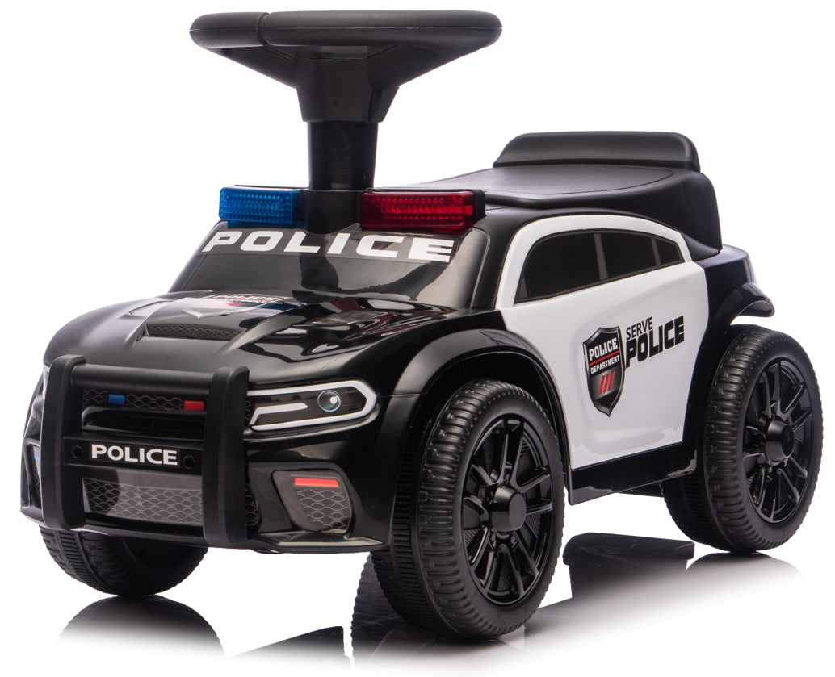

Product Reference Image

Testing and Records Overview
Test Date: 28 Aug, 2025
Aosom LLC
7777 Center Ave. Suite 430
Huntington Beach, CA 92647-9998 USA
Corey Shull
T:503.746.5886
corey@aosom.com
Intertek Testing Services Ltd .Zhejiang, Ningbo Branch
FULL MAILING ADDRESS: 4F's Area 2-3 , 5F, No.6 Building,Lingyun Industry Park, No.1177 Lingyun Road, Ningbo National Hi-Tech Zone, Ningbo,China,315000
Email:jim.wj.jin@intertek.com
TEL:+0086 13185982609

Certification Issued and Test Records Maintained By

Test Location and Contact Information

Aosom LLC certifies that the above product complies with the following rules, banes, regulations and standards:
U.S. ASTM F963-23 Physical and Mechanical Tests.
U.S. ASTM F963-23 Flammability Test of Materials other than Textile Materials
U.S. ASTM F963-23 Section 4.3.5.1 on Soluble Elements Content in Surface Coating
U.S. ASTM F963-23 Section 4.3.5.2 on Soluble Elements Content in substrate
U.S. ASTM F963-23 Section 4.3.5.2 on Total Lead Content in Substrate
U.S. ASTM F963-23 Section 4.3.5.1 on Total Lead Content in Surface Coating
Consumer Product Safety Act section 14(a)(5) tracking labels for Children Products
U.S. Consumer Product Safety Improvement Act 2008 title I, section 101 for total Lead content in non-surface coating materials (substrate)

US Consumer Product Safety Improvement Act 2008 Title I, Sec 108(a) & (b)(3) and US 16 CFR Part 1307 for Prohibition of Children’s Toys and Child Care Articles Containing Specified Phthalates
ASTM F963-23 Section 4.3.8 on Phthalates Content

