Children’s Product Certificate
Date of Certificate 15 Jun, 2026
Product Overview
Product name: BABY PUSH ON CAR.
Item Number: 370-521V00RD(6672)
Date of Manufacture: 1 July, 2026
Manufacture: YIWU ZHIHUIXING TOYS CO.,LTD
Address of Manufacture: 189 QIUSHI ROAD, BEIYUAN DISTRICT, YIWU, ZHEJIANG, CHINA.
Imported By: Imported by Aosom LLC
7777 Center Ave. Suite 430
Huntington Beach, CA 92647-9998 USA
corey@aosom.com
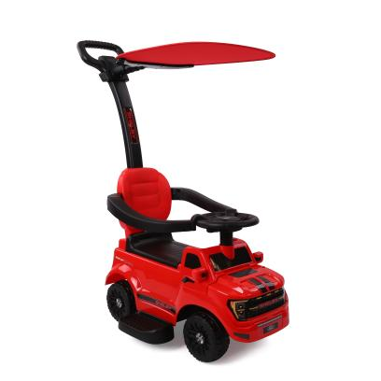

Product Reference Image

Testing and Records Overview
Imported by Aosom LLC
7777 Center Ave. Suite 430
Huntington Beach, CA 92647-9998 USA
Erin Flanagan
T:503.746.5886
PDreg@aosom.com

Intertek Testing Services Ltd .Zhejiang, Ningbo
Branch
4F's Area 2-3 , 5F, No.6 Building,Lingyun Industry
Park, No.1177 Lingyun Road, Ningbo National Hi-Tech
Zone, Ningbo,China,315000
Certification Issued and Test Records Maintained By
Aosom LLC certifies that the above product complies with the following rules, banes, regulations and standards:
Test Location and Contact Information
Test Date: 1 Apr, 2026
