Children’s Product Certificate
Date of Certificate Dec 31，2025
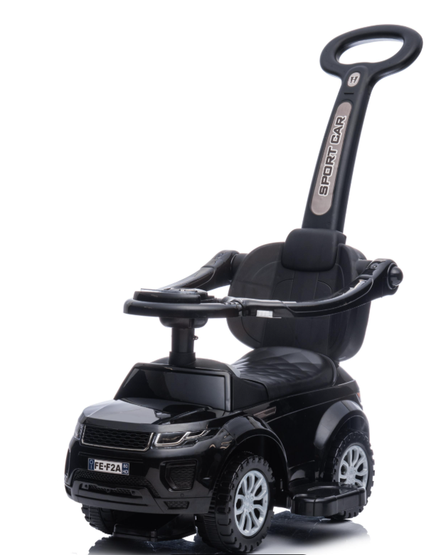

Product Overview
Product name: BABY RIDE ON CAR
Item Number: 370-116BK (614W)
Date of Manufacture: Nov 3,2025
Manufacture: NINGBO PRINCE TOYS CO.,LTD.
Address of Manufacture: NO.777 EAST TAOYUAN ROAD,GUANHAIWEI TOWN,CIXI CITY,ZHEJIANG,CHINA
Imported By: Aosom LLC
7777 Center Ave. Suite 430
Huntington Beach, CA 92647-9998 USA

Product Reference Image

Testing and Records Overview
Bureau Veritas Testing Technical Service
(Zhejiang) Co.,Ltd
1F west, 6F east, 7F east, 8F, Building B,
No.66,Qingyi Road, Ningbo, Zhejiang, China
Tel:86-574-87091333
lilyli.li@bureauveritas.com
Aosom LLC
7777 Center Ave. Suite 430
Huntington Beach, CA 92647-9998 USA
Corey Shull
Email:corey@aosom.com

Certification Issued and Test Records Maintained By
Aosom LLC certifies that the above product complies with the following rules, banes, regulations and standards:
Test Location and Contact Information
Test Date: Nov 3,2025

