Children’s Product Certificate
Date of Certificate 2025-12-22
Product Overview
Product name: Kids rocking horse
Item Number: 330-129
Date of Manufacture: 2025-12-22
Manufacture: Yizheng Jian Lin Arts Company
Address of Manufacture: Xianggou Village,Dayi Town,Yizheng City, Jiang Su Province ,China
Imported By: Aosom LLC
7777 Center Ave. Suite 430
Huntington Beach, CA 92647-9998 USA
T: 503.746.5886
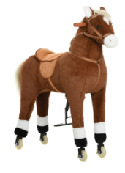

Product Reference Image

Testing and Records Overview
Bureau Veritas Testing Technical Service (Zhejiang) Co.,Ltd 1F west, 6F east, 7F east, 8F, Building B, No.66,Qingyi Road, Ningbo, Zhejiang, China, Tel:Tel:86-574-87091333
casey.jin@bureauveritas.com

Aosom LLC
7777 Center Ave. Suite 430
Huntington Beach, CA 92647-9998 USA
Erin Flanagan
T:503.746.5886
PDreg@aosom.com

Certification Issued and Test Records Maintained By
Aosom LLC certifies that the above product complies with the following rules, banes, regulations and standards:
Test Location and Contact Information
Test Date: 2025-12-22

