Children’s Product Certificate
Date of Certificate JUN 27, 2025
Product Overview
Product name: Disassemble and repair remote control vehicles
Item Number: 350-090 (008-958)
Date of Manufacture: MAY 1, 2025
Manufacture: XIONG CHENG PLASTIC TOYs CO.LTD
Address of Manufacture: CHENGHAl DISTRICT SHANTOU CITY GUANGDONG PROVINCE CHINA
Imported By: Aosom LLC
7777 Center Ave. Suite 430
Huntington Beach, CA 92647-9998 USA
Erin Flanagan
T:503.746.5886
PDreg@aosom.com
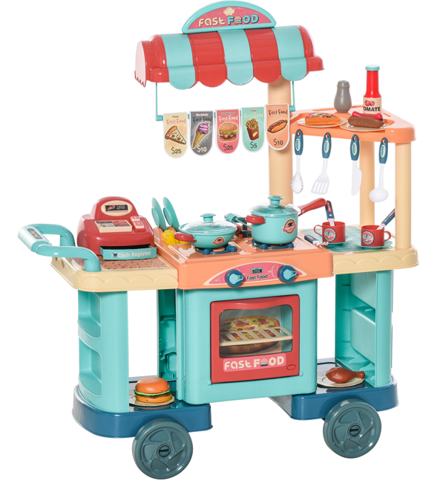

Product Reference Image

Testing and Records Overview
SGS-CSTC Standards Technical Co. Ltd
Shenzhen Branch
Room 101-901,1 Pant 4& Room 101, plant2& Room 101,
Pant 3& Rom 301-501, plant3, Janghao (Bantian) industrial
Plant Area, No.430, Jihua Road Bantian Cmmunity,
Batian Street, Longgang District, Shenzhen, Guangdong, China.
Tel:(86-755) 25328888
Sgs.china@sgs.com
Test Location and Contact Information
Certification Issued and Test Records Maintained By
Aosom LLCAosom LLC
7777 Center Ave. Suite 430
Huntington Beach, CA 92647-9998 USA
Erin Flanagan
T:503.746.5886
PDreg@aosom.com
Test Date: MAY 14,2025

Aosom LLC certifies that the above product complies with the following rules, banes, regulations and standards:
