Children’s Product Certificate
Date of Certificate April 09,2025
Product Overview
Product name: Children‘s electronic organ
Item Number: 390-020BU（3132C）
Date of Manufacture: Apr 09,2025
Manufacture: BANATOYS CO., LIMITED
Address of Manufacture: SHANTOU CITY, GUANGDONG PROVINCE
Imported By: Aosom LLC
7777 Center Ave. Suite 430
Huntington Beach, CA 92647-9998 USA
Erin Flanagan
T:503.746.5886
PDreg@aosom.com
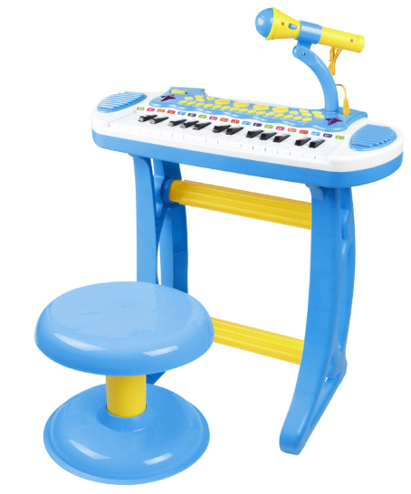

Product Reference Image

Testing and Records Overview
Aosom LLC
7777 Center Ave. Suite 430
Huntington Beach, CA 92647-9998 USA
Erin Flanagan
T:503.746.5886
PDreg@aosom.com
Intertek Testing Services Shenzhen Limited, Guangzhou Branch
Room 401/501/601/801/901/1003, No.8, East BaoYing Road,
Huangpu District. Guangzhou. China \111,Huichuang Kongjian. TCL Cultural Industrial Park, No.69,Guangpu Road, Huangpu District, Guangzhou, Guangdong.China.
Tel+8620 28209114
Jim.jin@intertek.com
Certification Issued and Test Records Maintained By
Aosom LLC certifies that the above product complies with the following rules, banes, regulations and standards:
Test Location and Contact Information
Test Date: April 09,2025
