Children’s Product Certificate
Date of Certificate 15 Jan, 2026

Product Overview
Product name: RIDE ON CAR
Item Number: 370-316V00PK(6551)
Date of Manufacture: 20 Jan, 2026
Manufacture: YIWU ZHIHUIXING TOYS CO.,LTD
Address of Manufacture: 189 QIUSHI ROAD, BEIYUAN DISTRICT, YIWU, ZHEJIANG, CHINA.
Imported By: Aosom LLC
7777 Center Ave. Suite 430
Huntington Beach, CA 92647-9998 USA
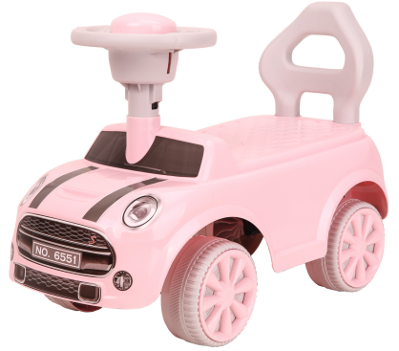

Product Reference Image

Testing and Records Overview
Aosom LLC
7777 Center Ave. Suite 430
Huntington Beach, CA 92647-9998 USA
corey@aosom.com

TÜV SÜD Certification and Testing (China) Co., Ltd. Shanghai Branch

Building B,C, No. 1999 and Building D, No. 2059, Duhui Road, Minhang District, Shanghai, China

Certification Issued and Test Records Maintained By
Aosom LLC certifies that the above product complies with the following rules, banes, regulations and standards:
Test Location and Contact Information
Test Date:15 Dec, 2025

