Children’s Product Certificate
Date of Certificate Sep 08,2025
Product Overview
Product name: Kids Tricycle
Item Number: 370-406V00PK(JY-T08F)
Date of Manufacture: Sep 05,2025
Manufacture: NINGBO ELITE CYCLECO., LTD.
Address of Manufacture: NO.36 PUYAN ROAD, XIAPU INDUSTRIAL PARK,BEILUN DISTRICT,NINGBO,Zhejiang,China
Imported By: Aosom LLC
7777 Center Ave. Suite 430
Huntington Beach, CA 92647-9998 USA
Erin Flanagan
T:503.746.5886
PDreg@aosom.com
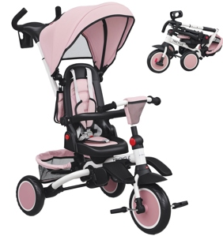

Product Reference Image

Testing and Records Overview
Aosom LLC
7777 Center Ave. Suite 430
Huntington Beach, CA 92647-9998 USA
Erin Flanagan
T:503.746.5886
TUV SUD Certification and Testing (China)Co., Ltd.Shanghai Branch,Testing Center
Building B,C,No.1999 and Building D, No.2059,
Duhui Road, Minhang District,Shanghai
Phone: +86 21 60376300
Fax: +862160376350
https://www.tuvsud.com
E-MAIL:RONGQI.LU@TUVSUD.COM
Test Date: May 16 ,2025
Test Location and Contact Information
Certification Issued and Test Records Maintained By
Aosom LLC certifies that the above product complies with the following rules, banes, regulations and standards:
