Children’s Product Certificate
Date of Certificate May 25,2023
Product Overview
Product name: kids sofa
Item Number: 310-056GY
Date of Manufacture: May 20,2023
Manufacture: Dongguan City Baby Furniture Co.,ltd
Address of Manufacture: Dangkeng Road,Shangtun No.3 Industrial Area, Liaobu Town, Dongguan City, China
Imported By: Aosom LLC
27150 SW Kinsman Rd
Wilsonville, OR 97070
T: 503.746.5886
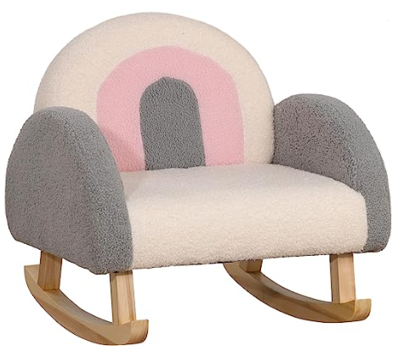

Product Reference Image

Testing and Records Overview
Bureau Veritas Shenzhen Co.,Ltd
1,2,3/F.,Block A,1,4,5/F.，Block B,Minlidalndustrial Building, Honghualing IndustrialPark, Xili,Nanshan District, Shenzhen,Guangdong, China.
Tel : 86-755-86185200
Fax: 86-755-86185206
www.bureauveritas.com/cps

Eurofins Product Testing Service (Shanghai) Co.,Ltd.Hangzhou Branch
Room 301-307,3/F.,Room 417-422,4/F.NO.1 Building 1,No.1180,Bin an Road,Binjiang Distict,Hangzhou, Zhejang. China
TEL:+86 57187203730
Email: info.hz@eurofins.com
Aosom LLC
27150 SW Kinsman Rd
Wilsonville, OR 97070
Corey Shull
T: 503.746.5886
Certification Issued and Test Records Maintained By
Aosom LLC certifies that the above product complies with the following rules, banes, regulations and standards:
Test Location and Contact Information
Test Date: May 09,2023
