Children’s Product Certificate
Date of Certificate 07-Aug, 2023
Product Overview
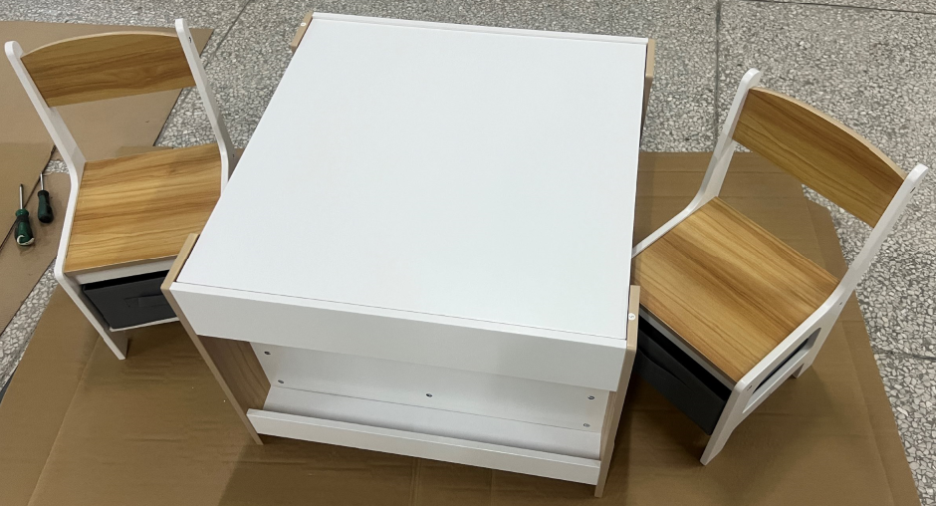

Product name: Kids Table and Chair Set
Item Number: 312-111V80ND
Date of Manufacture: 23-Feb, 2024
Manufacture: Fujian Senda Foreign Trade CO., LTD
Address of Manufacture: 22F ZHIDI PLAZA,NO.89 WUSI ROAD,FUZHOU,FUJIAN,CHINA
Imported By: Aosom LLC
27150 SW Kinsman Rd
Wilsonville, OR 97070
T: 503.746.5886

Product Reference Image

Testing and Records Overview
INTERTEK TESTING SERVICES LTD.
ZHEJIANG
Building No.2, Juanhu Science and Technology
Innovation Park, No. 500 East Shuiyueting Road,
Haining City, Zhejiang Province,China.
Phone: +86 573 87137200
www.intertek.com

Aosom LLC
27150 SW Kinsman Rd
Wilsonville, OR 97070
Corey Shull
T: 503.746.5886
Certification Issued and Test Records Maintained By
Aosom LLC certifies that the above product complies with the following rules, banes, regulations and standards:
Test Location and Contact Information
Test Date: 23-Feb, 2024
