Children’s Product Certificate
Date of Certificate 28-May, 2024
Product Overview
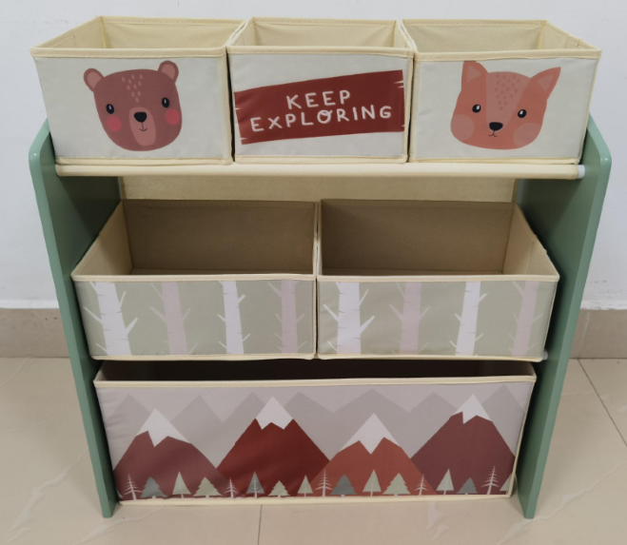
Product name: Green forest toy organizer with 1+2+3 bins
Item Number: 311-059V80GN
Date of Manufacture: 30-May, 2024
Manufacture: Fujian Senda Foreign Trade CO., LTD
Address of Manufacture: 22F ZHIDI PLAZA,NO.89 WUSI ROAD,FUZHOU,FUJIAN
Imported By: Aosom LLC
27150 SW Kinsman Rd
Wilsonville, OR 97070
T: 503.746.5886

Product Reference Image

Testing and Records Overview
Eurofins MTS Consumer Product Testing(Shanghai) Co., Ltd
No.105, Guanzhong Road,Minhan District, Shanghai, China
Phone: +86 21 3620 2800*6281
info.sh@eurofins.com

Aosom LLC
27150 SW Kinsman Rd
Wilsonville, OR 97070
Corey Shull
T: 503.746.5886
Certification Issued and Test Records Maintained By
Aosom LLC certifies that the above product complies with the following rules, banes, regulations and standards:
Test Location and Contact Information
Test Date: 08-May, 2024--24-May, 2024
