Children’s Product Certificate
Date of Certificate 05-Mar-2024
Product Overview
Product name: Kids Balance Board
Item Number: 331-036V00OG( LY-2417)
Date of Manufacture: 30-Apr-2024
Manufacture: Liyou Industrial Co.,Ltd
Address of Manufacture: Yangwan industrial area, QiaoXia Town, Yongjia County,Zhejiang 325106
Imported By: Aosom LLC
27150 SW Kinsman Rd
Wilsonville, OR 97070
T: 503.746.5886
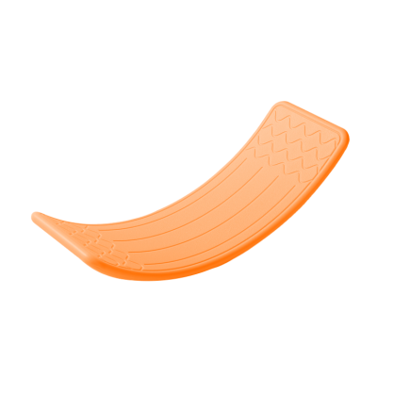

Product Reference Image

Testing and Records Overview
Aosom LLC
27150 SW Kinsman Rd
Wilsonville, OR 97070
Corey Shull
T: 503.746.5886
Certification Issued and Test Records Maintained By
Test Location and Contact Information
Eurofins MTS Consumer Product Testing (Shanghai) Co., Ltd
No.105, Guangzhong Road, Minhang,Shanghai, China
Phone:021-62819181
Fax:021-61819180
chinacomplaint@eurofins. Com

Test Date: 26-Feb-2024
Aosom LLC certifies that the above product complies with the following rules, banes, regulations and standards:

