Children’s Product Certificate
Date of Certificate 31-Oct-2025
Product Overview
Product name: Kids rocking horse
Item Number: 330-206V00GN
Date of Manufacture: 31-Oct-2025
Manufacture: Yizheng Jian Lin Arts Company
Address of Manufacture: Xianggou Village,Dayi Town,Yizheng City,Jiang Su Province ,China
Imported By: Aosom LLC
7777 Center Ave. Suite 430
Huntington Beach, CA 92647-9998 USA
T: 503.746.5886
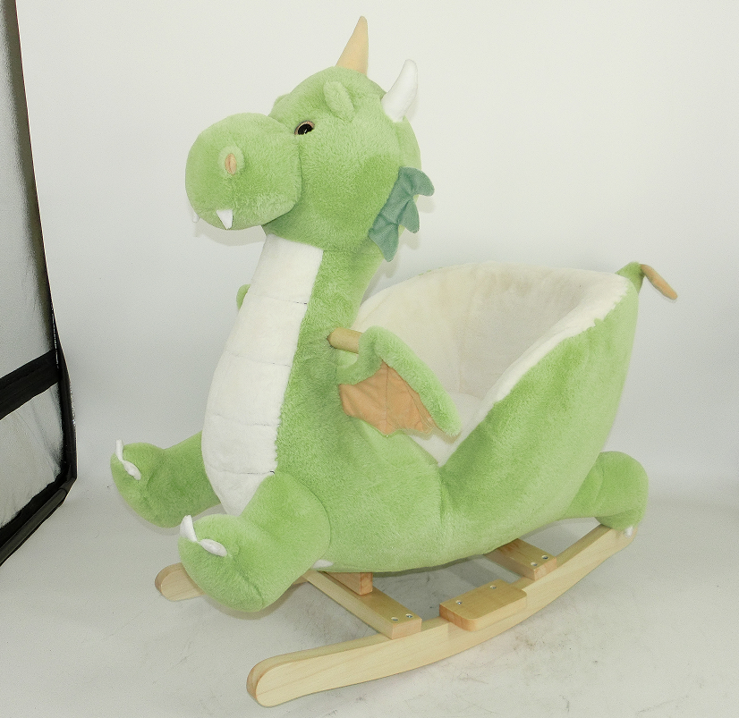

Product Reference Image

Testing and Records Overview

Eurofins MTS Consumer Product Testing (Shanghai) Co., Ltd.
No. 105, Guangzhong Road, Minhang Distict. Shanghai, China
Amy.Xu@cpt.eurofinscn.com
Tel：+86 2136202995#6161
Aosom LLC
7777 Center Ave. Suite 430
Huntington Beach, CA 92647-9998 USA
Erin Flanagan
T:503.746.5886
PDreg@aosom.com

Certification Issued and Test Records Maintained By
Aosom LLC certifies that the above product complies with the following rules, banes, regulations and standards:
Test Location and Contact Information
Test Date: 31-Oct-2025
